Optional and training assignments
Do what you can of the following assignments (Deliver it any time during the course):
- Make slide show that contain 7 images controls the first is left arrow, and the last is right arrow, and in between your images. Make the images interchanges 5 images in the time to be as if they moves (you have 10 pictures that interchanges) to left when the user keep click left arrow, and stop when release the left arrow, and the same for the right arrow. Change the shape of left, right arrows when they clicked down. And when user’s mouse over an image it shown larger above the slide show and description and date taken for it , and when it out it hide the larger image and description.



- Make a memory game using JavaScript, and handle time for the user to solve it, and after this time remove the event listener so user can’t click it again.

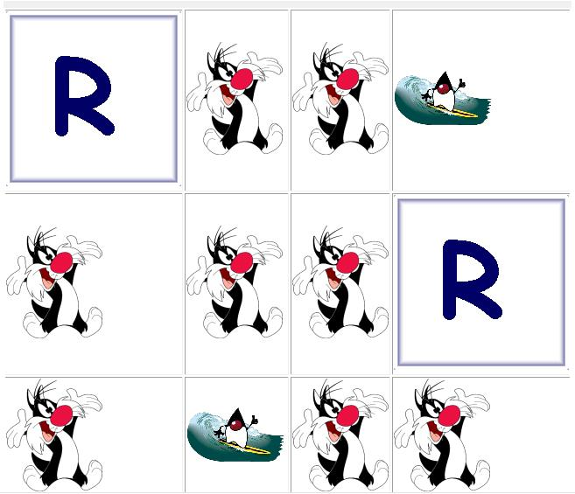

- Make Simple calculator as shown below using JavaScript (Use given HTML file named “Calculator.html”.
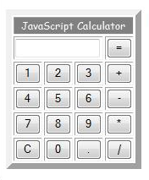

<Script>document.write(“Thank YOU”) </Script>

